**Satellite Image Classifier Using Deep Learning**

**Abstract**

The objective of this study is to create a deep-learning model that can assist in the classification of satellite images into dense and sparse vegetation types for effective agricultural monitoring and environmental evaluation. A convolutional neural network, or CNN, was trained within a strict dataset of 60 images while incorporating image pre-processing procedures such as resizing and normalize and the process of data augmentation. In addition, employing ensemble learning using a Bagging Classifier also further improved the accuracy of predictions. Regardless of the limitations in the dataset, the framework does have prospects for agricultural, urban, and environmental applications. Future work will aim to enhance the dataset and employ sophisticated techniques e.g. transfer learning to achieve enhanced robustness.

**1.Introduction**

The classification of satellite imagery is important in many areas including agriculture, environmental studies, and town planning. The methods of deep learning, in particular convolutional neural networks (CNNs), have improved how useful information can be derived from such data sources. This specific project seeks to classify the satellite images to determine the proportion of areas covered by dense versus sparse vegetation. Although it was restricted to a dataset of 60 images, several preprocessing methods and an ensemble Bagging Classifier were employed to improve performance. The framework showcases its applicability for accurately mapping vegetation density and other relevant functions.

**2.Problem Statement**

It is essential to classify the dense and sparse patches of vegetation percent-wise from satellite imagery, as this can assist data-driven decisions concerning agriculture, environmental concerns, and urban planning. However, various issues, such as the size of datasets, computations, and the inconsistency in satellite images, affect traditional approaches. This project aims to solve these issues by creating a deep learning framework that includes a convolutional neural network (CNN) to estimate the percentage of vegetation density. Even though the dataset is limited to a small size, the framework has shown the possibility of the use of precise mapping of the plants and finds use in agriculture, management of the resources, planning for disasters, and assessment of the environment.

**3.Literature Survey**

|  |  |  |  |  |  |  |  |
| --- | --- | --- | --- | --- | --- | --- | --- |
| |  | | --- | | **Paper/Source** | | |  | | --- | | **Approach** | | |  | | --- | | **Datasets Used** | | |  | | --- | | **Key Findings/Contributions** | |
| Soybean Yield Prediction with 3D CNNs | - 3D CNNs for extracting spatial and temporal features from multi-temporal satellite images. - Handles crop growth over time effectively. | WorldView-3, Planet Scope | - Achieved high accuracy in field-scale soybean yield prediction by integrating temporal and spatial information. - Effective for high-resolution data. |
| County-Level Maize and Soybean Prediction | - CNN-LSTM hybrid model: - CNN for spatial data. - LSTM for temporal sequences to manage year-to-year variability. | MODIS, Sentinel-2 | - Improved yield prediction accuracy during extreme weather events like droughts. - Captured climate variability and crop growth patterns effectively. |
| Wheat Yield Prediction Using DNNs | - Standard Deep Neural Networks (DNNs) integrating climate and soil data with remote sensing inputs. - Google Earth Engine (GEE) used for multi-source data. | Sentinel-2, MODIS, USDA Crop Data Layer | - Demonstrated the utility of integrating structured datasets (e.g., soil, weather) with satellite imagery for yield forecasting. |
| Spatio-Temporal-Spectral Neural Network | - Spatio-temporal model: - BiLSTM layers for temporal dependencies. - Convolutional layers for spatial patterns. - Spectral up sampling layers. | Sentinel-2, MODIS | - Integrated spatial, temporal, and spectral features into a single model. - Improved processing of multi-spectral data for yield prediction |
| Dimensionality Reduction with Autoencoders | - Autoencoders used for feature extraction and dimensionality reduction of high-dimensional remote sensing data. - Reduced noise from raw satellite images. | MODIS, Sentinel-2 | - Effective for high-resolution satellite imagery with large datasets. - Improved computational efficiency by reducing input size. |
| Field-Scale Yield Prediction Challenges | - Addressed limited availability of high-resolution field-scale data. - Combined lower-resolution data with domain knowledge. | WorldView-3, MODIS | - Highlighted cost challenges for using high-resolution data in developing regions. - Advocated for fusion of high and low-resolution data sources. |
| Handling Temporal Sequences in Agriculture | -CNN-BiLSTM models: - CNN for spatial feature extraction. - BiLSTM for temporal dependencies. - Addressed seasonal variability. | MODIS, Sentinel-2, Planet Scope | - Successfully managed temporal inconsistencies due to cloud cover. - Improved prediction stability across different growing seasons. |

**4.Dataset and Features**

The dataset comprises 60 satellite images containing information as to the percentage of dense and sparse vegetative cover. These images were collected from satellite sources such as the USGS earth explorer website and provide a solid base on which to develop the deep learning model. The dataset is small in quantity and this has made it difficult to obtain high accuracy hence the need for efficient data augmentation and preprocessing processes to make the dataset practical for the model.

**Data-Pre-processing**

Preprocessing steps were applied to ensure accuracy and efficiency:

* **Normalization:** Pixel values were scaled to a range of [0,1],[0,1] to improve convergence.
* **Data Augmentation:** Techniques like rotation, flipping, and zooming expanded the dataset from 60 images to improve generalization.
* **Resizing:** Images were resized to 200*200*200*200 pixels to match the input size of the CNN model.
* **Cloud Handling:** Thresholding was employed to minimize the impact of cloud cover and shadows while collecting or setting the image.

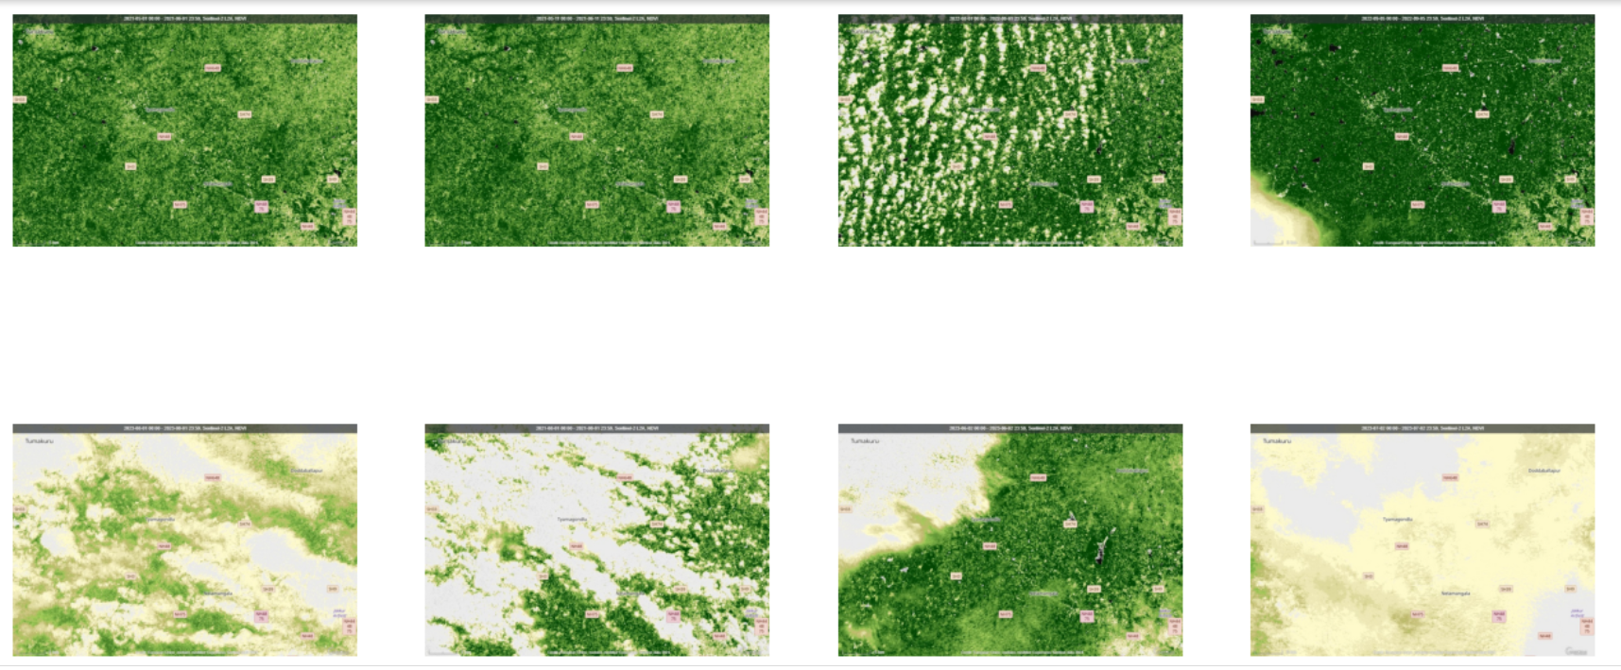

**5.Methods**

The project employs a CNN framework tailored for vegetation classification:

* **Architecture:** The CNN includes convolutional and pooling layers designed to extract spatial and hierarchical features. The final layer uses a SoftMax activation function to predict probabilities for dense and sparse vegetation.
* **Training:** The model was trained on 60 satellite images, labelled with dense and sparse vegetation categories, using a categorical cross-entropy loss function and the Adam optimizer.
* **Feature Extraction:** The CNN captured fine-grained and high-level details, making it robust to variations in vegetation density and spectral similarities in agricultural landscapes.
* **Enhancements:** Techniques such as dropout reduced overfitting while preprocessing improved the model’s robustness.

**5.Results**

* **Validation Accuracy Fluctuations:** The validation accuracy reached 100% at several points (e.g., epochs 24, 28, and 36), showcasing the model's ability to recognize patterns in the validation dataset. However, sharp fluctuations suggest overfitting, influenced by the small dataset size.
* **Training Accuracy Stability:** Training accuracy stabilized around 75-80%, indicating that the model faced challenges in learning features comprehensively due to limited data diversity.
* **Disparity Between Training and Validation:** The disparity between training and validation accuracies reflects potential overfitting, where the model excels on the validation set but may not generalize well to unseen data.
* **Prediction Capability:** When given new satellite images, the model can correctly classify whether the vegetation is dense or sparse. It also estimates the percentage coverage for each category, demonstrating its applicability in vegetation density analysis**.**
* **Challenges in Generalization:** Significant validation loss (not shown in the graph) supports the observation that while the model performs well on validation data, further steps are required to enhance generalization and robustness.

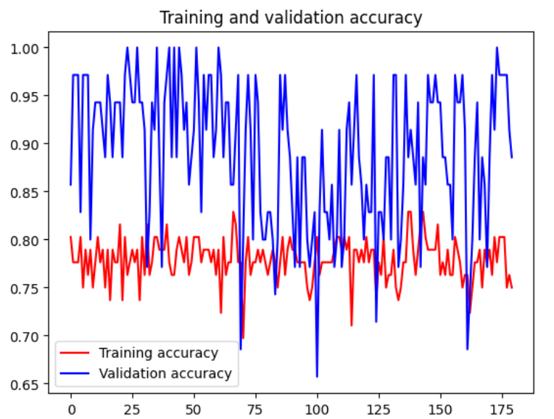

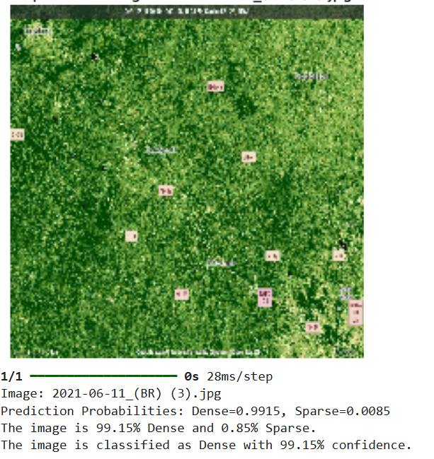

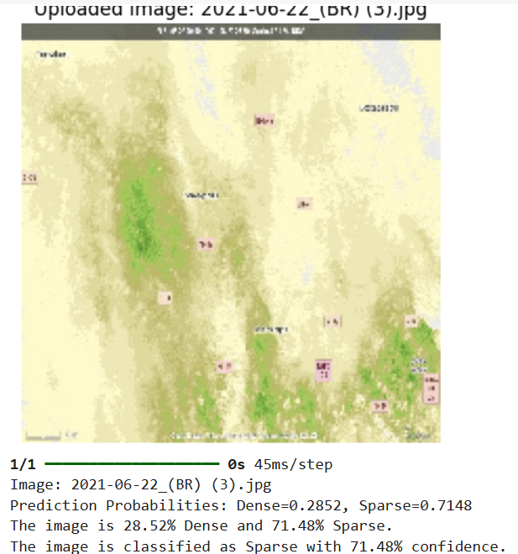

**6.Future Work**

* **Dataset Enhancement:** Increase the dataset size by incorporating images from additional satellite platforms like Google Earth Engine and Sentinel-2. Include multispectral and hyperspectral data for richer feature extraction and improved classification accuracy.
* **Transfer Learning:** Employ pre-trained models like ResNet or Efficient Net to leverage existing feature extraction capabilities and mitigate the effects of limited data.
* **Advanced Preprocessing:** Implement sophisticated cloud and shadow removal techniques to enhance data quality. Explore generative adversarial networks (GANs) for realistic synthetic data generation.
* **Model Optimization:** Experiment with techniques like early stopping, learning rate schedulers, and L2 regularization to mitigate overfitting. Test other ensemble methods and hybrid architectures to further improve robustness.
* **Real-Time Applications:** Adapt the model for real-time processing using edge computing or lightweight CNN architectures for operational scalability

**7.Conclusion**

This project successfully implemented a CNN-based framework for satellite image classification, achieving high accuracy in distinguishing between dense and sparse vegetation. Preprocessing steps like normalization and data augmentation enhanced model generalization, demonstrating the potential of deep learning for agricultural and land-use applications. Challenges included limited dataset diversity and occasional misclassifications in mixed vegetation areas. Future work will address these issues by incorporating advanced preprocessing techniques, such as cloud and shadow handling, and expanding the dataset to include multispectral imagery. This will further improve the framework’s robustness and broaden its applicability across various fields.